BUYER BEWARE - THE TRUTH ABOUT NO OR LOW GRAIN DIETS
The pet food industry is a very competitive one, 22 billion $ in 2014! Companies spend lots of money on marketing that isn't supported with scientific evidence or by your Veterinarians here at GBAC. The latest trend is the GRAIN FREE DIET. Feeding a grain free diet to your K9 family member without the recommendation from your Dr. is not beneficial, likely a waste of money and also potentially harmful. Claims that No or Low grain foods prevent food allergies are inaccurate. Corn and other grains are not recognized as a highly allergenic food. Typically, allergies are to the protein (meat) source and not the carbohydrate (grain).
Here's Why No/Low Grain Diets for healthy K9 is not advise: Taurine
Taurine, an amino acid that is essential (must be in the diet) for dogs and cats, but not humans is found in the GRAIN portion of your pet's diet. Taurine provides HEALTHY HEART MUSCLE development and function.
Feeding your dog a grain free diet may result in a heart condition called Dilated Cardiomyopathy, DCM, a disease of the heart muscle. Weakened muscle contractions mean poor heart pumping ability. As this disease progresses complications include an enlarged heart with leaky valves, abnormal rhythms and congestive heart failure.
Research has shown low levels of Taurine in the blood of dogs that are on No/Low grain diets. As we have seen more of our patients eating raw and or Low/No grain diets we have begun recommended testing of Taurine blood levels in those pets.
We are here to answer any questions about the best diet choices for your K9 family member. Please ask anytime, or at your next visit. We can give you recommendations for a variety of high quality, reputable dog foods available on the market.
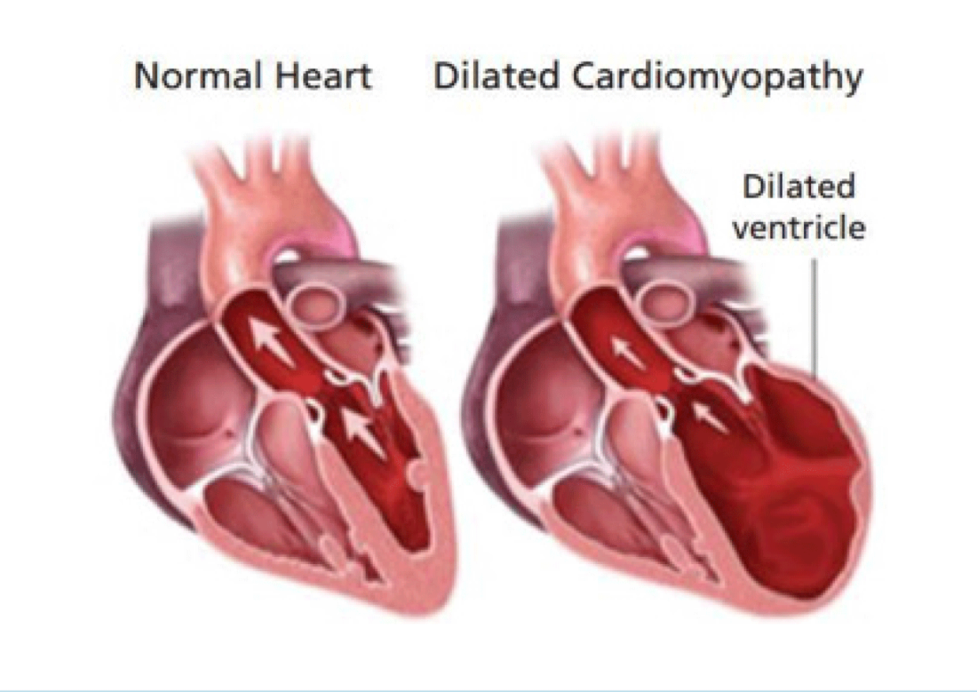
Be an informed pet owner.
Thank you,
Dr. B and Dr. H

